Section 1: Complex Queries with Joins

- Library Book Inventory Report:
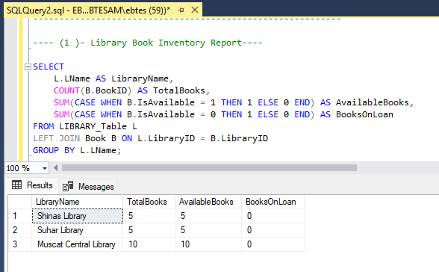

- Active Borrowers Analysis
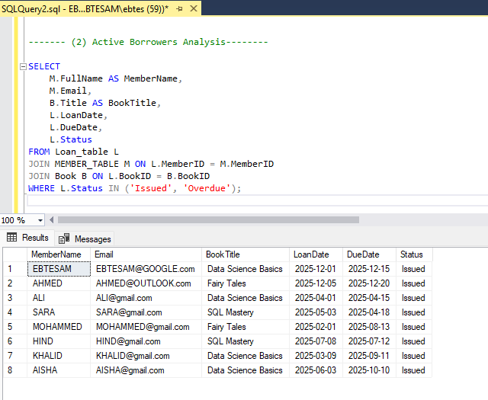

- Overdue Loans with Member Details:
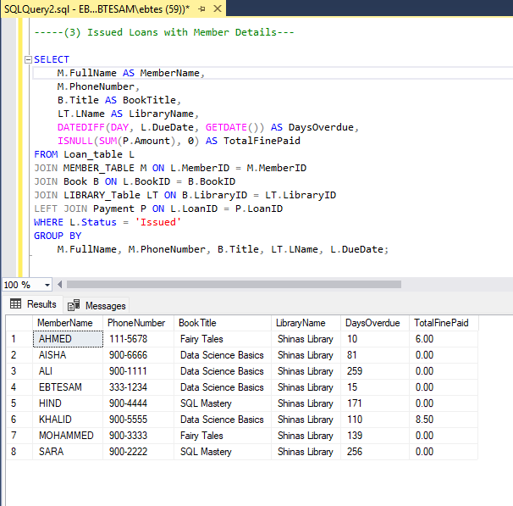

- Staff Performance Overview:
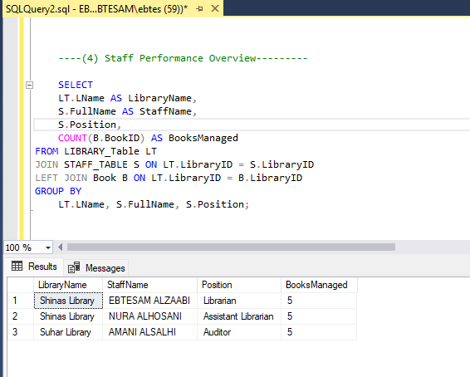

- Book Popularity Report:
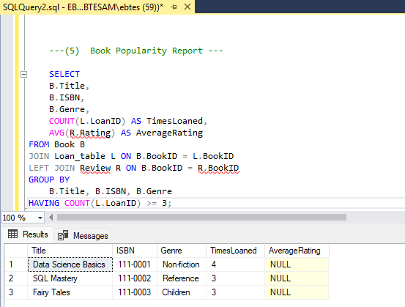

-- This query generates a report of the most popular books in the library database. Popularity is measured by the number of times a book has been borrowed. Additionally, it calculates the average rating of each book based on member reviews.
Average rating uses COALESCE to handle books without reviews.

- Member Reading History:
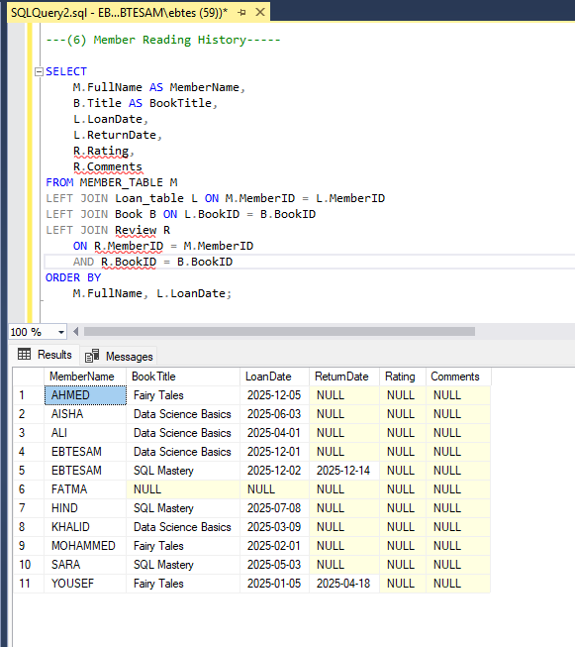
This query shows the complete borrowing history of each library member, including both currently borrowed and previously returned books. It also includes any reviews they left for the books.

- Revenue Analysis by Genre:

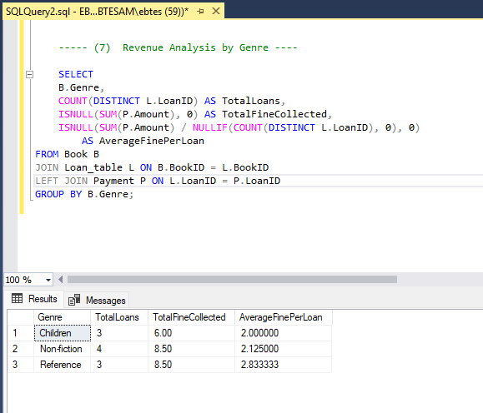
This query calculates the total fines collected per book genre, total number of loans for each genre, and the average fine per loan. It helps the library understand which genres generate the most revenue from fines.

Section 2: Aggregate Functions and Grouping

- Monthly Loan Statistics:
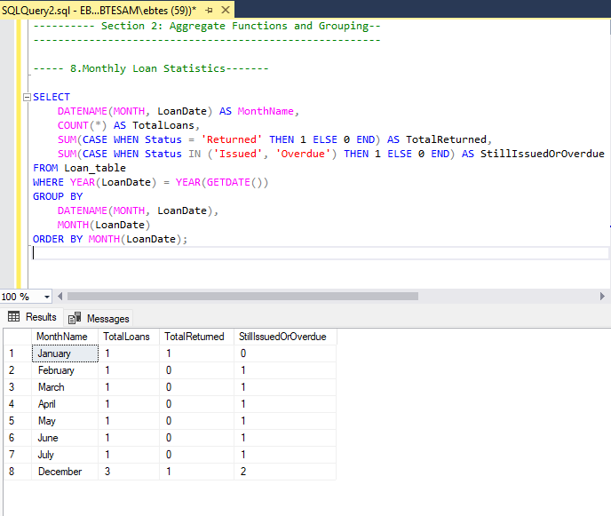

- Member Engagement Metrics:
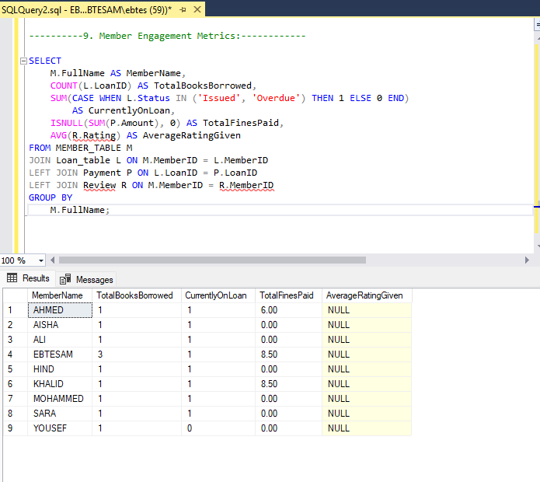

- Library Performance Comparison
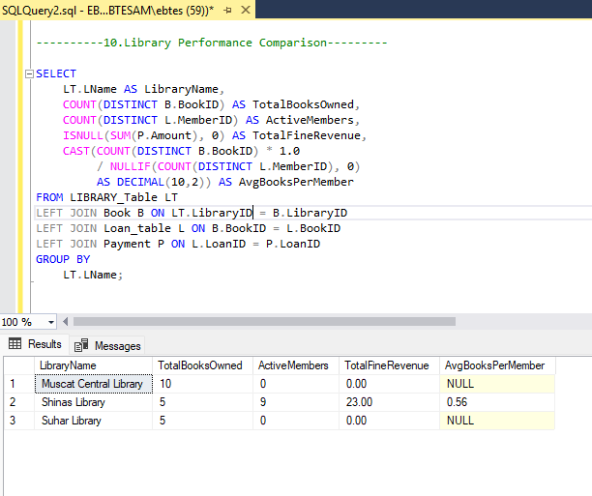

- High-Value Books Analysis
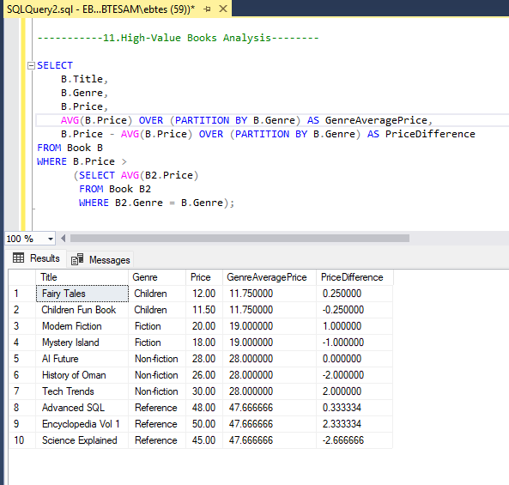

- Payment Pattern Analysis:
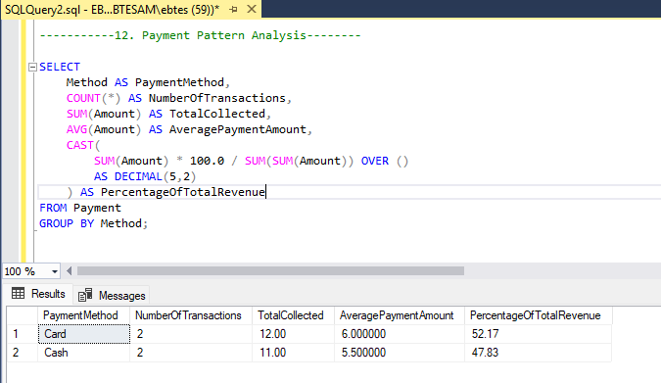
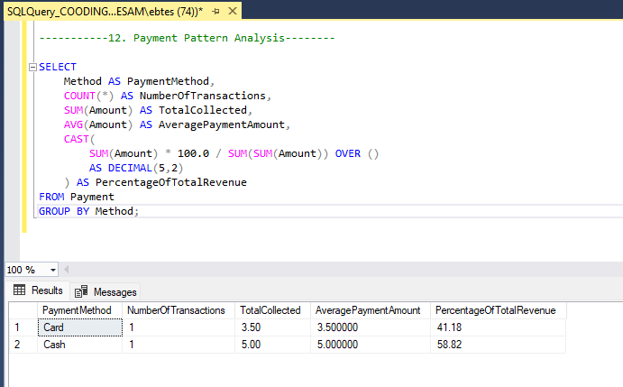

Section 3: Views Creation

- vw_CurrentLoans
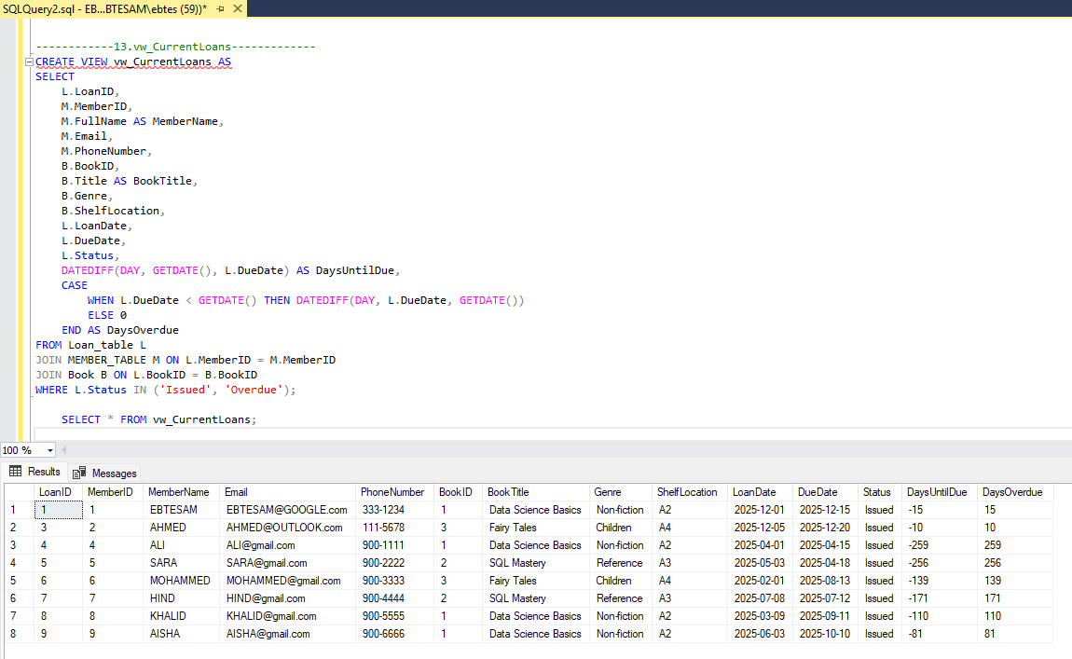
- . Vw _Library Statistics
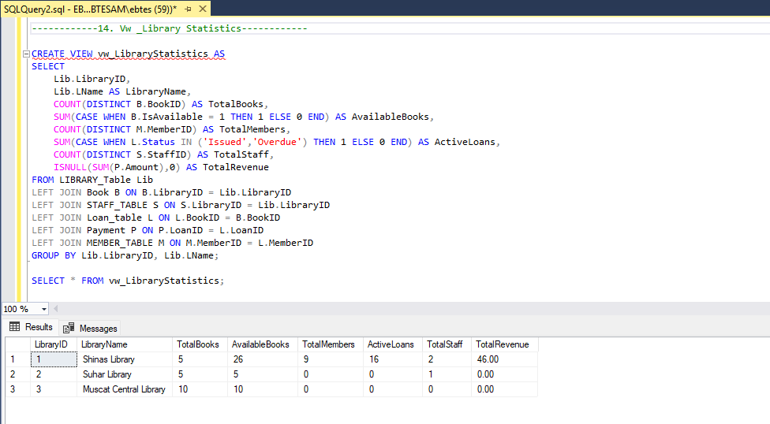

- Vw _Book Details With Reviews
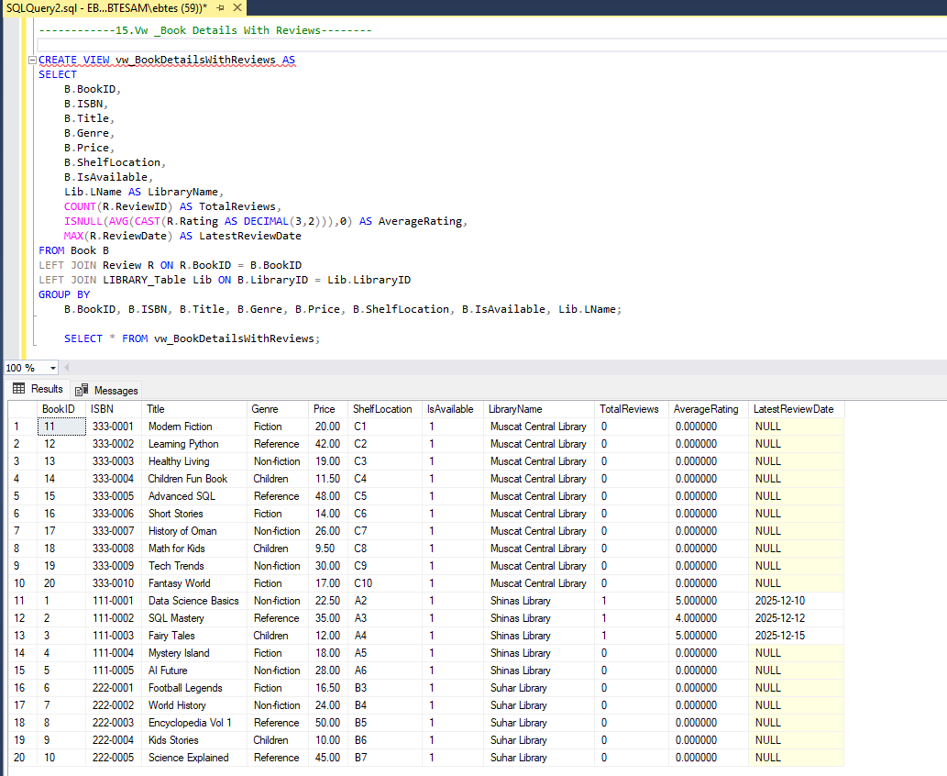

Section 4: Stored Procedures

- sp_IssueBook
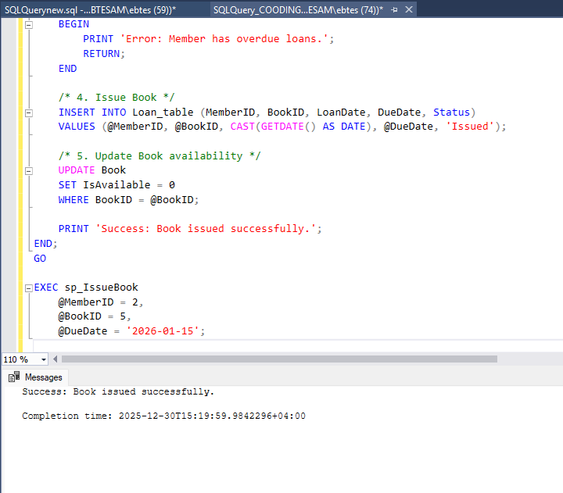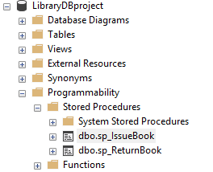

- sp_ReturnBook
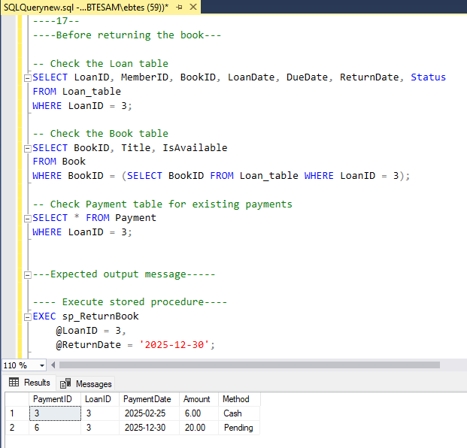
- sp_GetMemberReport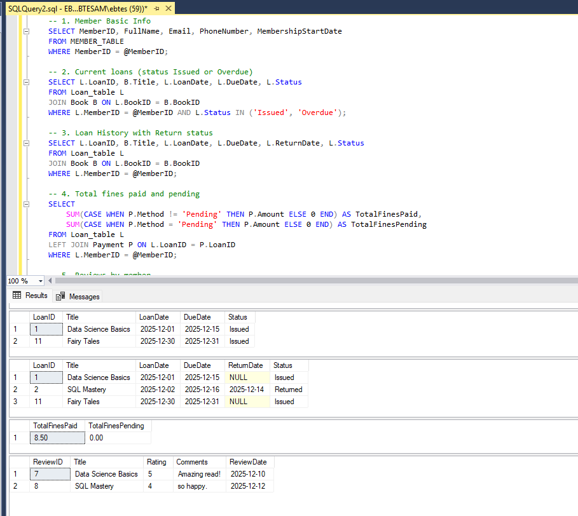
- 19. sp_MonthlyLibraryReport
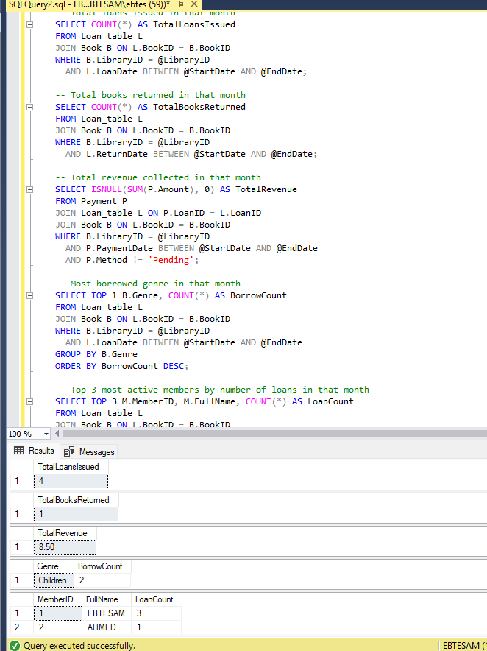

2. Documentation Document

Explanation of how your stored procedures handle edge cases:
Stored Procedure | Edge Case / Scenario | How It’s Handled
sp_IssueBook | Book does not exist | Checks BookID in Book table; raises error 'Book not found.'
 | Book is not available | Checks IsAvailable = 1; if 0, returns error 'Book is not available.'
 | Member has overdue loans | Checks Loan_table for Status = 'Overdue'; prevents issuing another loan if overdue exists
 | Successful loan | Inserts new Loan_table record, updates Book.IsAvailable = 0, returns success message
sp_ReturnBook | Loan record does not exist | Checks LoanID in Loan_table; raises error 'Loan record not found.'
 | Return date earlier than loan date | chk_ReturnDate constraint prevents invalid return dates
 | Book returned late | Calculates DaysOverdue; computes fine (DaysOverdue * 2)
 | Update book availability | Sets Book.IsAvailable = 1
 | Successful return | Prints total fine amount (even if 0)
sp_GetMemberReport | Member does not exist | Returns empty result sets; no errors thrown
 | Member has no current loans | Current loans result set is empty (LEFT JOIN ensures member still appears)
 | Member has no past loans | Loan history result set is empty
 | Member has no fines | Total fines shows 0 using ISNULL
 | Member has not written reviews | Reviews result set is empty
sp_MonthlyLibraryReport | Library does not exist | Returns empty or NULL values
 | No loans in specified month | Total loans and returned books show 0
 | No payments/fines | Total revenue shows 0 using ISNULL
 | No loans for a genre | Most borrowed genre may return NULL

Important Notes

3Library:
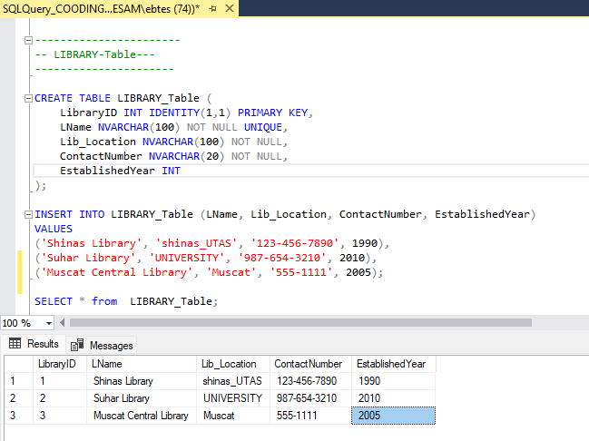

20 book:
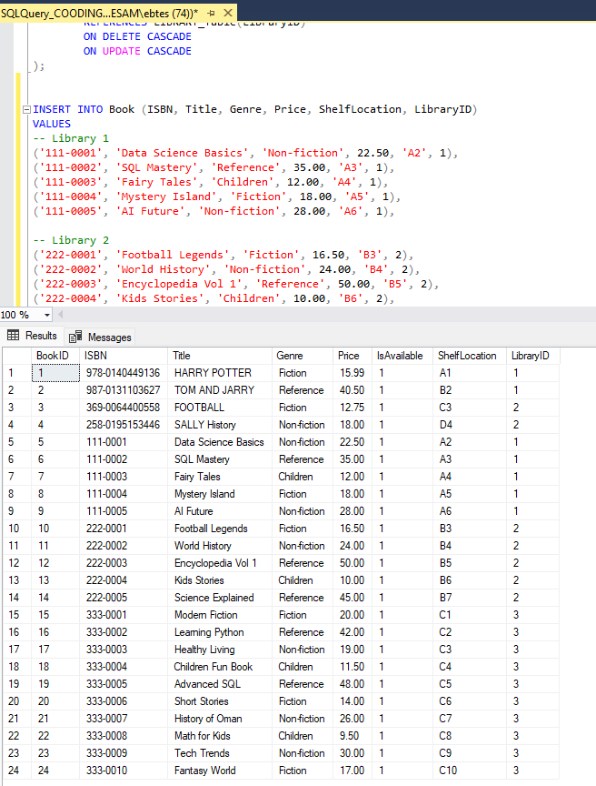

10member:
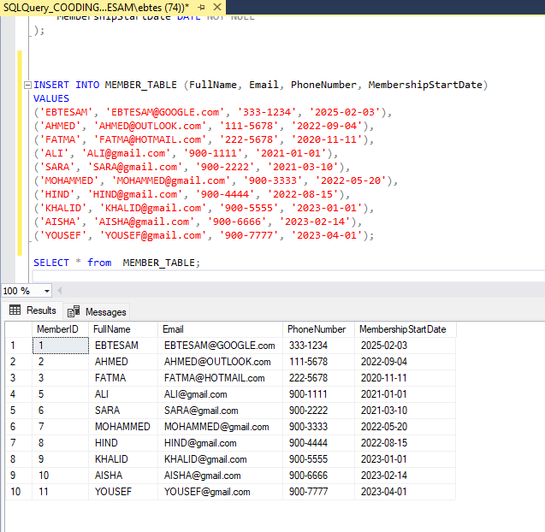

10 loan
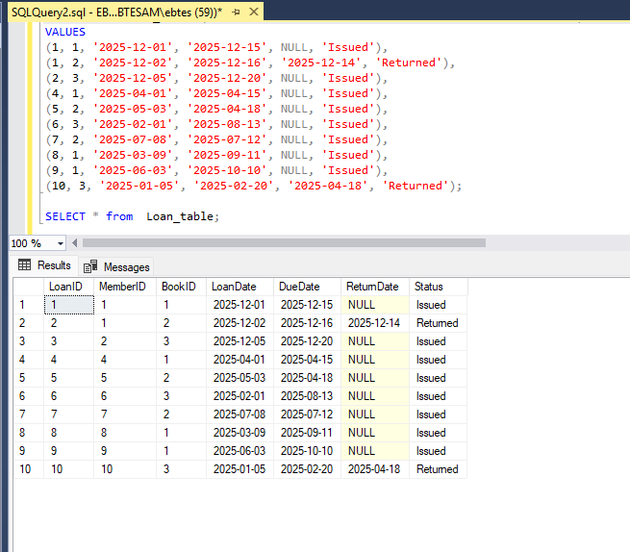

4payment
